MAINTAINCE SHEET FOR GC-NET v3
Station name: | NSE |  | Date: | 01-05-2026
People present: | RSF, RABNI, IASTE, ARU |  | Maintenance |  | Install | Take-down | Data Download

Weather: | Sunny, high clouds

METADATA
 | Arrival | Departure
Download Data | YES / NO | NA
Time difference between logger and UTC (± mm:ss) | : | :
Screenshot of ‘Status’ table | YES / NO | YES / NO
Screenshot of ‘Public’ table in FastScan mode | YES / NO | YES / NO
Photos of mast, loggerbox and sensors (inc. radiometer serial) | YES / NO | YES / NO

STATION POSITON AND OREINTATION
 |  |  | Arrival |  | Departure
Lower lufft height (see A) |  |  | 188 cm |  | 300 cm
Lower SR50 height (see A) |  |  | 145 cm |  | 265 cm
Upper lufft height (see A) |  |  | 320 cm |  | 425 cm
Upper SR50 height (see A) |  |  | 260 cm |  | 380 cm
Upper boom direction (towards radiometer, see B) |  |  | 338 degree mag. |  | 338 degree mag.
Lower boom direction (towards lufft, see B) |  |  | 248 degree mag. |  | 248 degree mag.
Upper wind sensor orientation (away from black box, see C) |  |  | Yes |  | Yes
Lower wind sensor orientation (away from black box, see C) |  |  | Broken |  | Yes
Radiometer across-boom tilt, looking at the front (see D) |  |  | 4 degree to right/east |  | NA
Mast tilt north-south axis |  |  | 5 degree down-north |  | 0 degree
Mast tilt east-west axis |  |  | 1 degree to right/east |  | 2 degree right/east
Height of thermistor string pipe above surface |  |  | 28 cm |  | 230 cm
Depth of snowboard | NA | Height of snowboard stake |  | NA Vertical: YES / NO
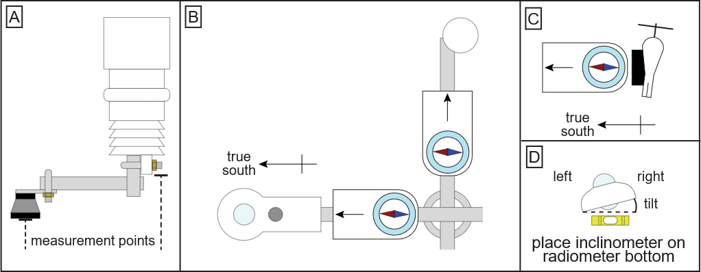

Station name: | NSE |  | Date: | 01-05-2026
STATION HARDWARE
To do? | Done? | Item | Comments
Update program | yes | Loggerbox | ID arrival: M3 – 03  ID departure: M3-03
 |  | Modem IMEI | IMEI arrival: 300534063818800  IMEI departure: 300534063818800
 |  | Radiometer | Serial arrival: 244328  Serial departure: 244328
Replace | Yes | Wind sensor upper | Type arrival: Black / White  Type departure: Black / White
Replace | Yes | Wind sensor lower | Type arrival: Black / White  Type departure: Black / White
Replace | Yes | Lufft upper
Replace | Yes | Lufft lower
Replace | Yes | SR50 upper
Replace | Yes | SR50 lower
 |  | Thermistor string
 |  | Iridium antenna
 |  | Solar panel
Replace | Yes | Battery box | Burial under lower lufft: YES / NO  Location if NO:
Replace | Yes | Mast

NOTES (e.g. sensor damage, must-do at next visit)
We did not find old snowboard stake
New snowboard top 250 cm
No liquid GNSS installed
New loggerbox for next year: Unstable USB connection port on logger
New solar panel: Plug is damaged.

